Exercise 1:
LibraryManagementApplication.java
package com.library;
import com.library.service.BookService;
import org.springframework.context.ApplicationContext;
import org.springframework.context.support.ClassPathXmlApplicationContext;
public class LibraryManagementApplication {
public static void main(String[] args) {
ApplicationContext context =
new ClassPathXmlApplicationContext("applicationContext.xml");
BookService service =
context.getBean("bookService", BookService.class);
service.display();
}
}
applicationContext.xml
<?xml version="1.0" encoding="UTF-8"?>
<beans xmlns="http://www.springframework.org/schema/beans"
xmlns:xsi="http://www.w3.org/2001/XMLSchema-instance"
xsi:schemaLocation="
http://www.springframework.org/schema/beans
https://www.springframework.org/schema/beans/spring-beans.xsd">
<bean id="bookRepository"
class="com.library.repository.BookRepository"/>
<bean id="bookService"
class="com.library.service.BookService"/>
</beans>

BookRepository.java
package com.library.repository;
public class BookRepository {
public void display() {
System.out.println("Book Repository Created");
}
}
BookService.java
package com.library.service;
public class BookService {
public void display() {
System.out.println("Book Service Created");
}
}

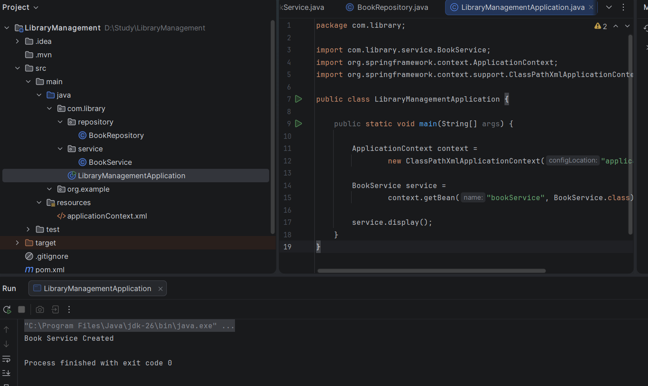

Exercise 2:
applicationContext.xml
<?xml version="1.0" encoding="UTF-8"?>
<beans xmlns="http://www.springframework.org/schema/beans"
xmlns:xsi="http://www.w3.org/2001/XMLSchema-instance"
xsi:schemaLocation="
http://www.springframework.org/schema/beans
https://www.springframework.org/schema/beans/spring-beans.xsd">
<bean id="bookRepository"
class="com.library.repository.BookRepository"/>
<bean id="bookService"
class="com.library.service.BookService">
<property name="bookRepository" ref="bookRepository"/>
</bean>
</beans>
BookService.java
package com.library.service;
import com.library.repository.BookRepository;
public class BookService {
private BookRepository bookRepository;
public void setBookRepository(BookRepository bookRepository) {
this.bookRepository = bookRepository;
}
public void display() {
System.out.println("Book Service Created");
bookRepository.display();
}
}
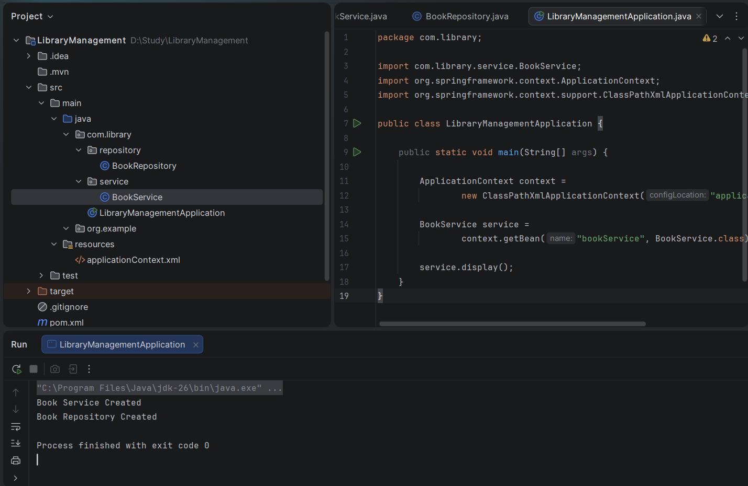

Exercise 3:
LoggingAspect.java
package com.library.aspect;
import org.aspectj.lang.ProceedingJoinPoint;
import org.aspectj.lang.annotation.Around;
import org.aspectj.lang.annotation.Aspect;
@Aspect
public class LoggingAspect {
@Around("execution(* com.library.service.*.*(..))")
public Object logExecutionTime(ProceedingJoinPoint joinPoint) throws Throwable {
long start = System.currentTimeMillis();
Object result = joinPoint.proceed();
long end = System.currentTimeMillis();
System.out.println(joinPoint.getSignature().getName()
+ " executed in "
+ (end - start)
+ " ms");
return result;
}
}

applicationContext.xml

<?xml version="1.0" encoding="UTF-8"?>
<beans xmlns="http://www.springframework.org/schema/beans"
xmlns:xsi="http://www.w3.org/2001/XMLSchema-instance"
xmlns:aop="http://www.springframework.org/schema/aop"
xsi:schemaLocation="
http://www.springframework.org/schema/beans
https://www.springframework.org/schema/beans/spring-beans.xsd
http://www.springframework.org/schema/aop
https://www.springframework.org/schema/aop/spring-aop.xsd">
<bean id="bookRepository"
class="com.library.repository.BookRepository"/>
<bean id="bookService"
class="com.library.service.BookService">
<property name="bookRepository" ref="bookRepository"/>
</bean>
<bean id="loggingAspect"
class="com.library.aspect.LoggingAspect"/>
<aop:aspectj-autoproxy/>
</beans>
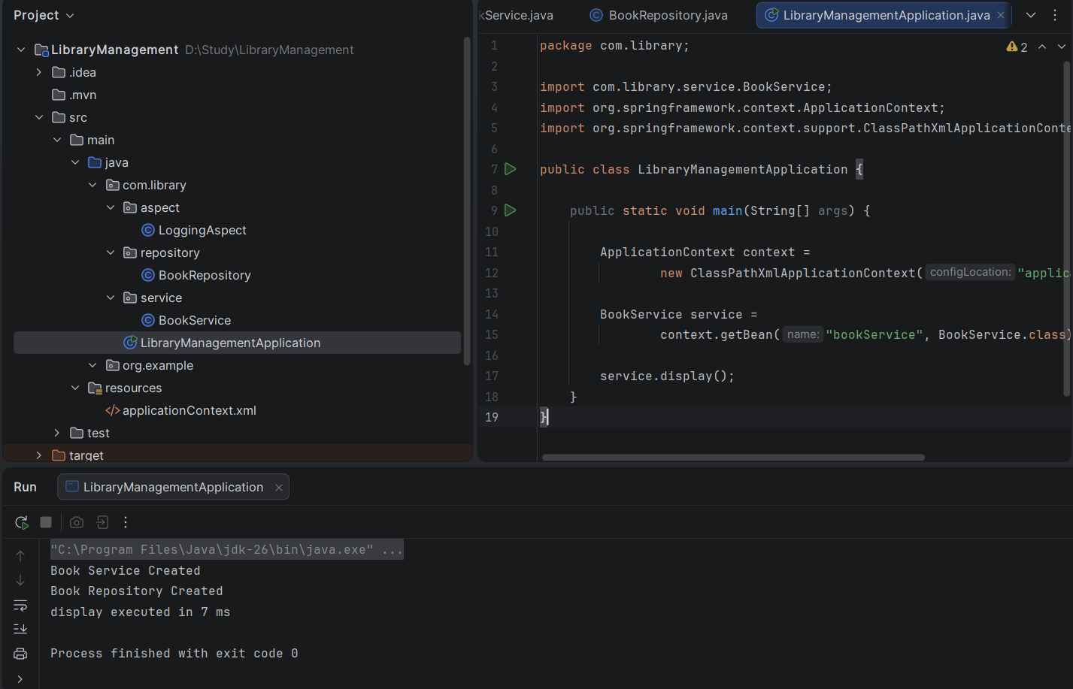

Exercise 4:


Exercise 5:
LibraryManagementApplication.java
package com.library;
import com.library.service.BookService;
import org.springframework.context.ApplicationContext;
import org.springframework.context.support.ClassPathXmlApplicationContext;
public class LibraryManagementApplication {
public static void main(String[] args) {
ApplicationContext context =
new ClassPathXmlApplicationContext("applicationContext.xml");
BookService service =
context.getBean("bookService", BookService.class);
service.display();
}
}

BookService.java
package com.library.service;
import com.library.repository.BookRepository;
public class BookService {
private BookRepository bookRepository;
public void setBookRepository(BookRepository bookRepository) {
this.bookRepository = bookRepository;
}
public void display() {
System.out.println("Book Service Created");
bookRepository.display();
}
}
BookRepository.java
package com.library.repository;
public class BookRepository {
public void display() {
System.out.println("Book Repository Created");
}
}
applicationContext.xml
<?xml version="1.0" encoding="UTF-8"?>
<beans xmlns="http://www.springframework.org/schema/beans"
xmlns:xsi="http://www.w3.org/2001/XMLSchema-instance"
xmlns:aop="http://www.springframework.org/schema/aop"
xsi:schemaLocation="
http://www.springframework.org/schema/beans
https://www.springframework.org/schema/beans/spring-beans.xsd
http://www.springframework.org/schema/aop
https://www.springframework.org/schema/aop/spring-aop.xsd">
<bean id="bookRepository"
class="com.library.repository.BookRepository"/>
<bean id="bookService"
class="com.library.service.BookService">
<property name="bookRepository" ref="bookRepository"/>
</bean>
<bean id="loggingAspect"
class="com.library.aspect.LoggingAspect"/>
<aop:aspectj-autoproxy/>
</beans>
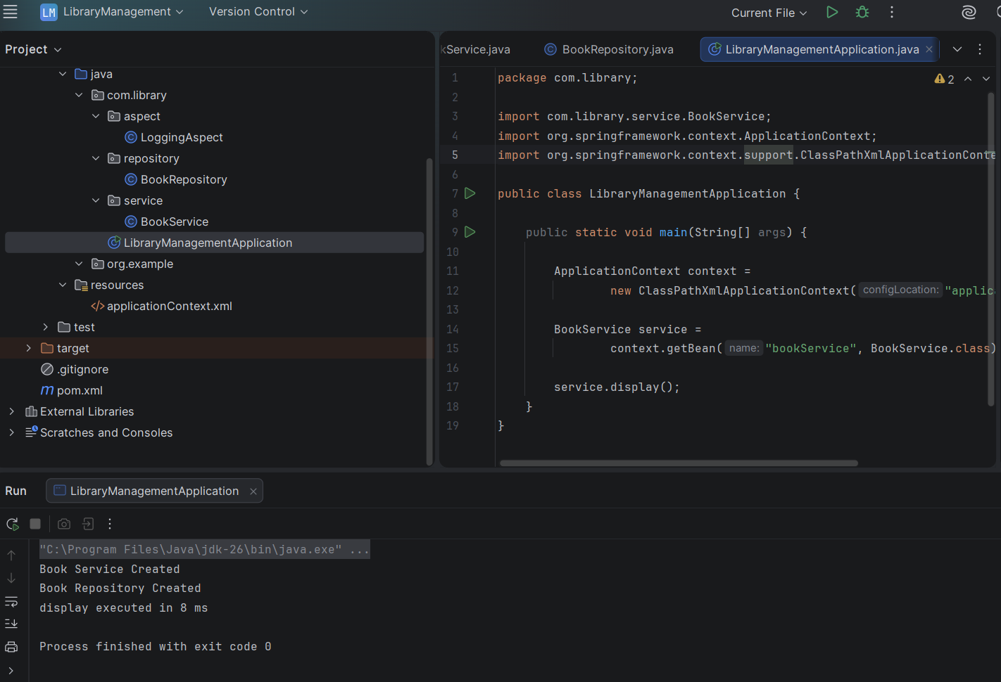

Exercise 6:
LibraryManagementApplication.java
package com.library;
import com.library.service.BookService;
import org.springframework.context.ApplicationContext;
import org.springframework.context.support.ClassPathXmlApplicationContext;
public class LibraryManagementApplication {
public static void main(String[] args) {
ApplicationContext context =
new ClassPathXmlApplicationContext("applicationContext.xml");
BookService service =
context.getBean(BookService.class);
service.display();
}
}
BookService.java
package com.library.service;
import com.library.repository.BookRepository;
import org.springframework.beans.factory.annotation.Autowired;
import org.springframework.stereotype.Service;
@Service
public class BookService {
@Autowired
private BookRepository bookRepository;
public void display() {
System.out.println("Book Service Created");
bookRepository.display();
}
}

BookRepository.java
package com.library.repository;
import org.springframework.stereotype.Repository;
@Repository
public class BookRepository {
public void display() {
System.out.println("Book Repository Created");
}
}
applicationContext.xml
<?xml version="1.0" encoding="UTF-8"?>
<beans xmlns="http://www.springframework.org/schema/beans"
xmlns:xsi="http://www.w3.org/2001/XMLSchema-instance"
xmlns:context="http://www.springframework.org/schema/context"
xmlns:aop="http://www.springframework.org/schema/aop"
xsi:schemaLocation="
http://www.springframework.org/schema/beans
https://www.springframework.org/schema/beans/spring-beans.xsd
http://www.springframework.org/schema/context
https://www.springframework.org/schema/context/spring-context.xsd
http://www.springframework.org/schema/aop
https://www.springframework.org/schema/aop/spring-aop.xsd">
<context:component-scan base-package="com.library"/>
<bean id="loggingAspect"
class="com.library.aspect.LoggingAspect"/>
<aop:aspectj-autoproxy/>
</beans>
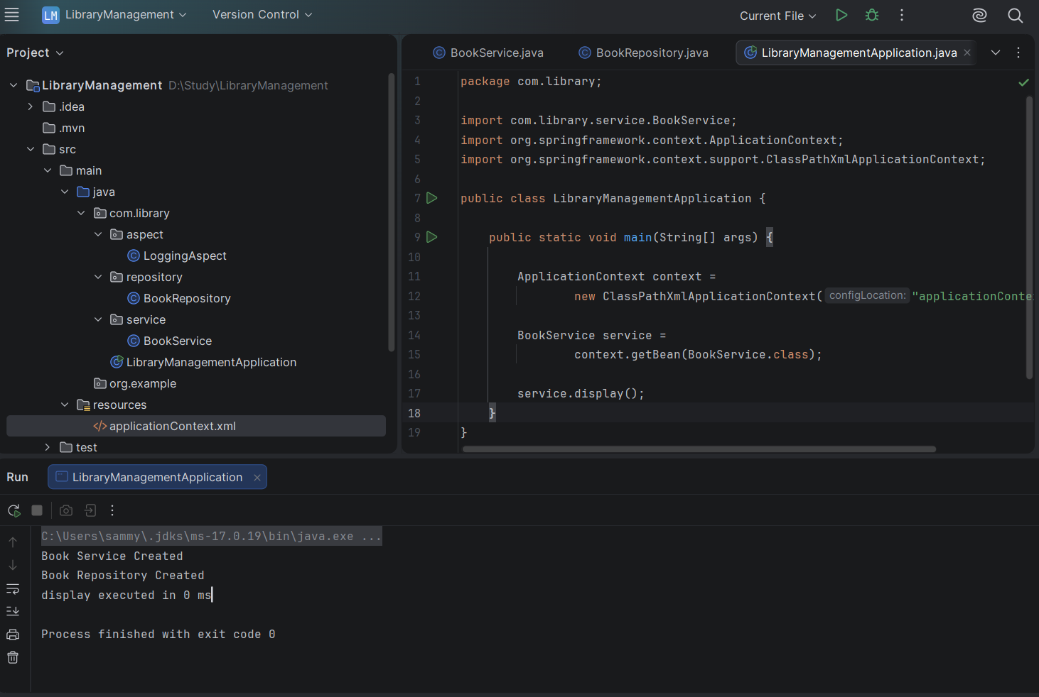

Exercise 7:
applicationContext.xml
<?xml version="1.0" encoding="UTF-8"?>
<beans xmlns="http://www.springframework.org/schema/beans"
xmlns:xsi="http://www.w3.org/2001/XMLSchema-instance"
xsi:schemaLocation="
http://www.springframework.org/schema/beans
https://www.springframework.org/schema/beans/spring-beans.xsd">
<bean id="bookRepository" class="com.library.repository.BookRepository"/>
<bean id="bookService" class="com.library.service.BookService">
<constructor-arg ref="bookRepository"/>
<property name="bookRepository" ref="bookRepository"/>
</bean>
</beans>

BookService.java
package com.library.service;
import com.library.repository.BookRepository;
import org.springframework.stereotype.Service;
@Service
public class BookService {
private BookRepository bookRepository;
public BookService(BookRepository bookRepository) {
this.bookRepository = bookRepository;
}
public void setBookRepository(BookRepository bookRepository) {
this.bookRepository = bookRepository;
}
public void display() {
System.out.println("Book Service Created");
bookRepository.display();
}
}
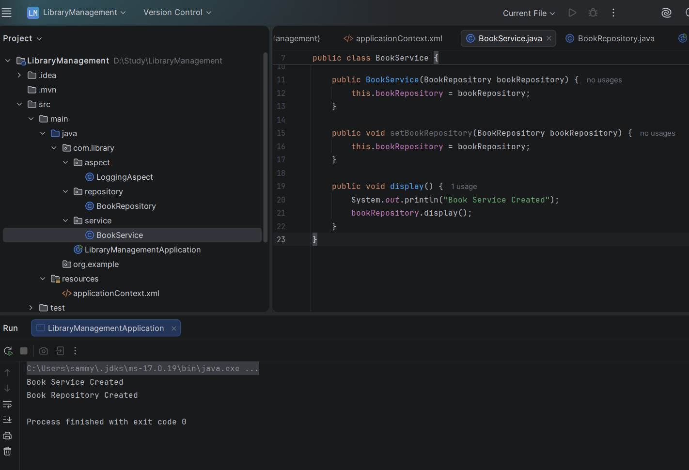

Exercise 8:
LoggingAspect.java
package com.library.aspect;
import org.aspectj.lang.annotation.After;
import org.aspectj.lang.annotation.Aspect;
import org.aspectj.lang.annotation.Before;
import org.springframework.stereotype.Component;
@Aspect
@Component
public class LoggingAspect {
@Before("execution(* com.library.service.BookService.display(..))")
public void beforeDisplay() {
System.out.println("Before method execution");
}
@After("execution(* com.library.service.BookService.display(..))")
public void afterDisplay() {
System.out.println("After method execution");
}
}

applicationContext.xml
<?xml version="1.0" encoding="UTF-8"?>
<beans xmlns="http://www.springframework.org/schema/beans"
xmlns:xsi="http://www.w3.org/2001/XMLSchema-instance"
xmlns:context="http://www.springframework.org/schema/context"
xmlns:aop="http://www.springframework.org/schema/aop"
xsi:schemaLocation="
http://www.springframework.org/schema/beans
https://www.springframework.org/schema/beans/spring-beans.xsd
http://www.springframework.org/schema/context
https://www.springframework.org/schema/context/spring-context.xsd
http://www.springframework.org/schema/aop
https://www.springframework.org/schema/aop/spring-aop.xsd">
<context:component-scan base-package="com.library"/>
<aop:aspectj-autoproxy/>
</beans>

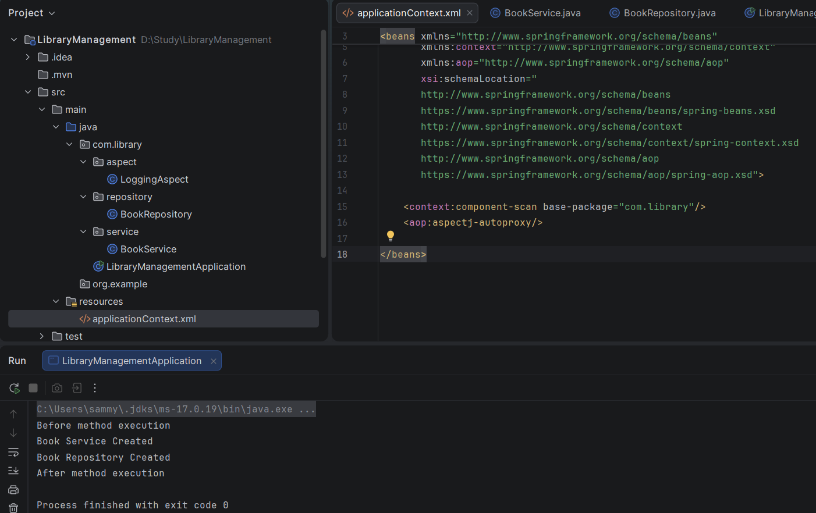

Exercise 9:
application.properties
spring.datasource.url=jdbc:h2:mem:librarydb
spring.datasource.driverClassName=org.h2.Driver
spring.datasource.username=sa
spring.datasource.password=
spring.jpa.hibernate.ddl-auto=update
spring.jpa.show-sql=true
spring.h2.console.enabled=true
spring.h2.console.path=/h2-console

Book.java
package com.library.entity;
import jakarta.persistence.*;
@Entity
public class Book {
@Id
@GeneratedValue(strategy = GenerationType.IDENTITY)
private Long id;
private String name;
private String author;
public Book() {
}
public Book(Long id, String name, String author) {
this.id = id;
this.name = name;
this.author = author;
}
public Book(String name, String author) {
this.name = name;
this.author = author;
}
public Long getId() {
return id;
}
public void setId(Long id) {
this.id = id;
}
public String getName() {
return name;
}
public void setName(String name) {
this.name = name;
}
public String getAuthor() {
return author;
}
public void setAuthor(String author) {
this.author = author;
}
}

BookRepository.java
package com.library.repository;
import com.library.entity.Book;
import org.springframework.data.jpa.repository.JpaRepository;
public interface BookRepository extends JpaRepository<Book, Long> {
}

BookController.java
package com.library.controller;
import com.library.entity.Book;
import com.library.repository.BookRepository;
import org.springframework.web.bind.annotation.*;
import java.util.List;
import java.util.Optional;
@RestController
@RequestMapping("/books")
public class BookController {
private final BookRepository bookRepository;
public BookController(BookRepository bookRepository) {
this.bookRepository = bookRepository;
}
@GetMapping
public List<Book> getAllBooks() {
return bookRepository.findAll();
}
@GetMapping("/{id}")
public Optional<Book> getBookById(@PathVariable Long id) {
return bookRepository.findById(id);
}
@PostMapping
public Book addBook(@RequestBody Book book) {
return bookRepository.save(book);
}
@PutMapping("/{id}")
public Book updateBook(@PathVariable Long id, @RequestBody Book book) {
book.setId(id);
return bookRepository.save(book);
}
@DeleteMapping("/{id}")
public String deleteBook(@PathVariable Long id) {
bookRepository.deleteById(id);
return "Book deleted successfully";
}
}

LibraryManagementApplication.java
package com.library;
import org.springframework.boot.SpringApplication;
import org.springframework.boot.autoconfigure.SpringBootApplication;
@SpringBootApplication
public class LibraryManagementApplication {
public static void main(String[] args) {
SpringApplication.run(LibraryManagementApplication.class, args);
}
}
